|  |  |  |  |
| --- | --- | --- | --- |
| **F:\Learning bugs\Foundation Subjects\Dolly the Fly - Science.jpgLyng Primary School Knowledge Organiser** | | | |
| **Science** | **Comparing animals** | **Year 1** | **Summer** |

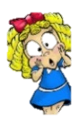

|  |  |
| --- | --- |
| **What Step On and Goldilocks words will I use?** | |
| **Spelling** | **Definition** |
| amphibian | Small animals which need to live near water to survive. |
| bird | A warm-blooded animal with feather and wings. They lay eggs. |
| reptile | A cold blooded animal with scales. They lay eggs. |
| mammal | A warm blooded animal with hair or fur. They give birth to live young and feed them milk from their bodies. |
| carnivore | An animal which eats only meat. |
| herbivore | The part of a flowering plant that can grow into a new plant |
| omnivore | Animals which eat meat and plants. |

C:\Users\dominic.cooper\AppData\Local\Microsoft\Windows\INetCache\Content.MSO\A3480DB6.tmp

|  |
| --- |
| **Investigate!** |
| * How plants grow. * Grow plants from seed and observe them as they grow and change. * Identify different parts of a plant. |
| Enquiry Question |
| * What is an animal? * Can I describe animals? * Can I compare animals? * Carnivore, herbivore or omnivore? * Are all the pets the same? |

**What will I know by the end of the unit?**

|  |  |  |  |
| --- | --- | --- | --- |
| Comparing animals | |  |  |
| **What is an animal?**  Identify and name a variety of common animals including fish, amphibians, reptiles, birds and mammals. |  | **Carnivore, herbivore or omnivore?**  Identify animals that are carnivores, herbivores and omnivores. |  |
| **Can I describe animals?**  Describe and compare the structure of a variety of common animals (fish, amphibians, reptiles, birds and mammals, including pets). |  | **Are all the pets the same?**  Find out which animals that make suitable pets. |  |
| **Can I compare animals?**  Compare the structure of a variety of common animals (fish, amphibians, reptiles, birds and mammals, including pets). |  | **Who is Jane Goodall?**  To know about famous scientists throughout history. |  |

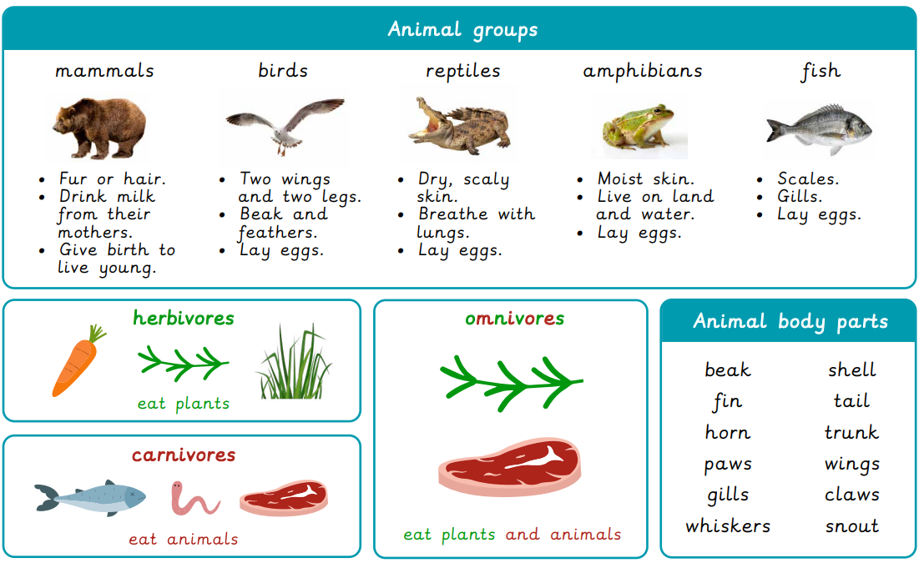

|  |  |  |  |
| --- | --- | --- | --- |
| **F:\Learning bugs\Foundation Subjects\Dolly the Fly - Science.jpgLyng Primary School Knowledge Organiser** | | | |
| **Science** | **Plants** | **Year 1** | **Summer** |

|  |  |  |  |
| --- | --- | --- | --- |
| 1. I give birth to live young.  What am I? | **start** | | **end** |
| 1. A fish |  |  | |
| 1. A bird |  |  | |
| 1. A mammal |  |  | |

|  |  |  |
| --- | --- | --- |
| 4. What does an omnivore eat? | **start** | **end** |
| 1. animals and plants |  |  |
| 1. only animals |  |  |
| 1. Only plants |  |  |

|  |  |  |
| --- | --- | --- |
| 5. What type of animal are these? | **start** | **end** |
| 1. reptiles |  |  |
| 1. amphibians |  |  |
| 1. fish |  |  |
| 1. mammals |  |  |

|  |  |  |
| --- | --- | --- |
| 1. What do all birds have in common? | **start** | **end** |
| 1. They can fly |  |  |
| 1. They lay eggs. |  |  |

|  |  |  |
| --- | --- | --- |
| 1. Which type of animal does not lay eggs? | **start** | **end** |
| 1. fish |  |  |
| 1. mammals |  |  |
| 1. birds |  |  |